The following essay question is designed as a POST-VISIT assessment to incorporate the subject matter addressed during the shipboard programming at Patriots Point:

(5-1.6, 5-2, 5-3.6, 5-4.8, 5.S.1A.5, 5.E3.B, 5.L4.A, 5.L4.B)
There are many processes and factors that impact coastal ecosystems in South Carolina, some natural and some not. Imagine there has been a large oil spill in Charleston Harbor. You are a science news reporter and it is your job to explain to the citizens of Charleston what effects the oil spill could have on Charleston Harbor’s ecosystems. The graph below is research you have uncovered on a past oil spill. Using what you learned during your visit to the USS Yorktown and the graph below as evidence, write an article on WHY this oil spill should be cleaned up immediately! Please include at least 4 of the words from the word bank below:

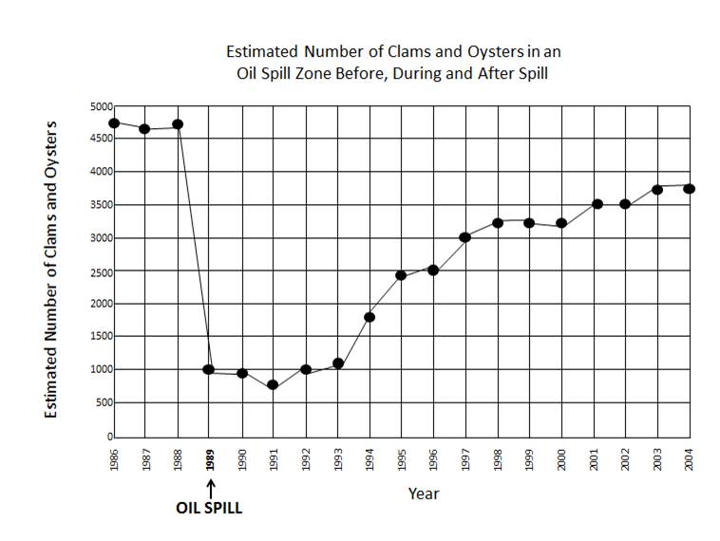
WORD BANK:

Ecosystem
Estuary
Food Chain
Producer
Consumer
Limiting Factors
Abiotic
Biotic
Tide
Pollution
Communication
Team Work

