Middle School Flight Academy Program
8th Grade Curriculum Standards Covered
Math Standard 8-4
- Students will be using Pythagorean Theorem to triangulate the location of targets as well as the trajectory of ordinance used.
- Students will be charting the location of elements within the Flight Academy mission as well as calculating the distance and heading these elements are from a relative location.

Science Standard 8.P.2
- Students will learn about and use the four forces of flight. These forces are thrust, drag, lift, and gravity.
- Students will use the distance, rate, time triangle to calculate these elements as pertaining to the mission.

History Standard 8-6
- Students will execute this program on the USS Yorktown. The USS Yorktown was engaged in the WWII, Korean, and Vietnam conflicts.
- Students will learn elements of the Doolittle raid during calculation of factors to execute the mission.
Other Topics Covered
- Students will be provided responsibilities that must be accurately executed in order for the entire team to be successful.
- Students will engage in precise communication that determines the success of the mission.
- Students will be put in hierarchal order and have their leadership skills tested.

Practice Questions
- If the TARGET that you are engaging is 9 nautical miles away from the AIRPORT in Subic Bay, and it is 12 nautical miles from the AIRPORT to the USS YORKTOWN, how far away is the TARGET from the USS YORKTOWN?
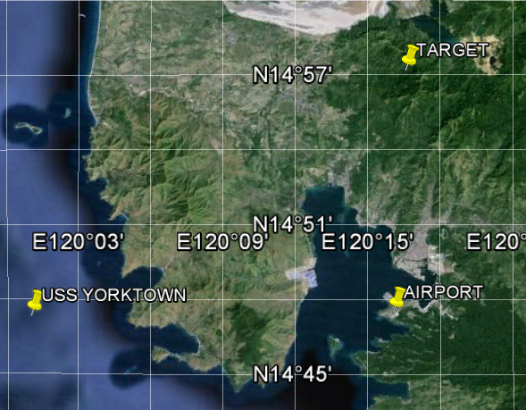
- You just found out that there are 5 targets that need to be engaged. 3 targets are to the northeast of the USS Yorktown and 2 targets are to the southwest. You have 4 aircraft in your squadron, how would you approach this situation?
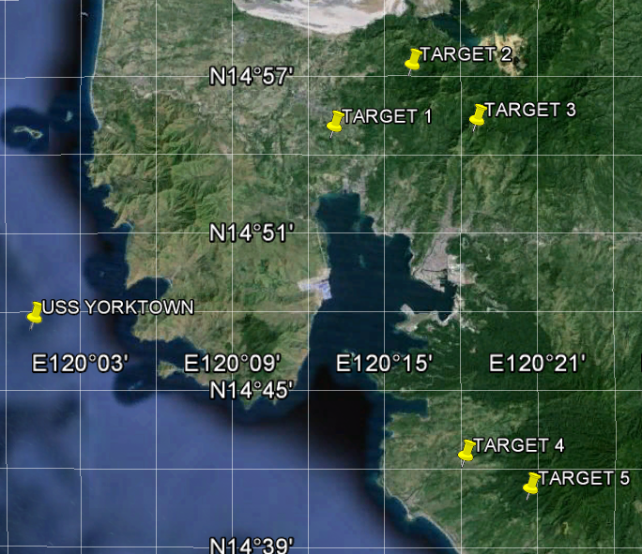
- What was the most significant aspect of the Doolittle Raid? What was the most important force that acted on the aircraft and had to be adjusted? Why?
- What are the coordinates of the target?
- What heading would you advise a pilot to take to reach the target from the USS Yorktown (heading is the degree bearing to be traveled)?
- What distance is the target away from the USS Yorktown?
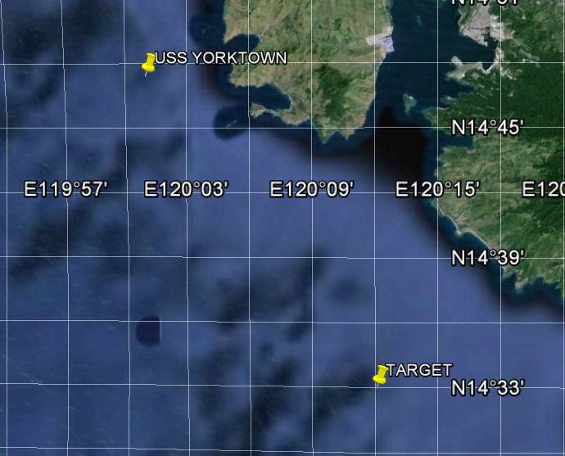
- If an aircraft is traveling 300 knots per hour, how many nautical miles per minute are they traveling?
- How many minutes would it take the aircraft to reach the target?
- If the distance from the Lockheed Martin F-35B to the front of the ship is 556 ft, and the ship is 100 ft long then how far will ordinance have to drop to hit the ship on target?

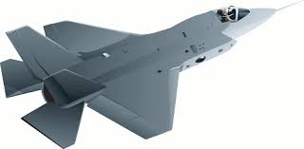

?? 556 ft

100ft

